Function Based Index Demo

Login as DBA.

Remove all the cached data from buffer, all the sql statements from shared pool and set the tracing on by executing the following 3 commands.

Alter system flush buffer_cache;
Alter system flush shared_pool;
SET AUTOTRACE ON

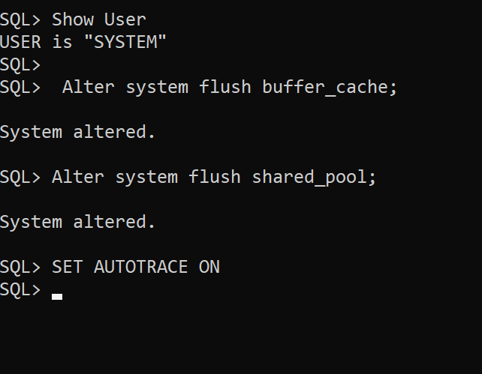

The Scott user’s Emp table has employee names stored in upper case.

Index is created for the employee name (Ename) column

create index Scott_Emp_Ename
On Scott.Emp(Ename);

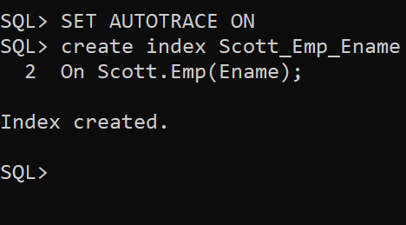

Reset commands:

Alter system flush buffer_cache;
Alter system flush shared_pool;
SET AUTOTRACE ON

But the query is different. It is using the Oracle function Initcap (capitalizes first alphabet only) to filter Smith’s record.

Select *
From Scott.Emp
Where Initcap(Ename) = 'Smith';

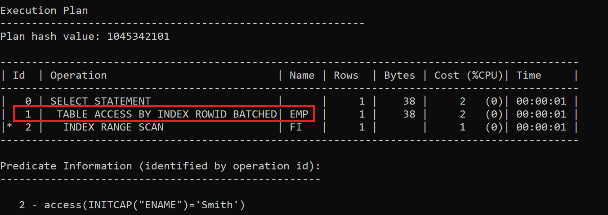

Notice that a full table scan has happened, which will slow down the query execution.

Drop that index as anyhow it is not getting used.

Drop Index Scott_Emp_Ename;

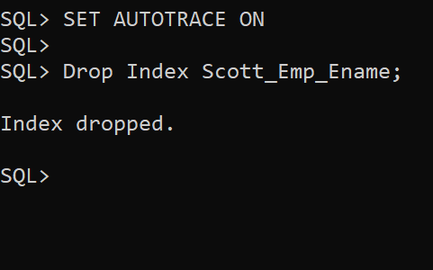

Again, remove all the cached data from buffer, all the sql statements from shared pool and set the tracing on by executing the following 3 commands.

Alter system flush buffer_cache;
Alter system flush shared_pool;
SET AUTOTRACE ON

Now let’s create a B-Tree index on Ename column. But the Initcap function will be used while creating the index.

Create Index Scott_Emp_Ename_Initcap
on Scott.Emp(Initcap(Ename));

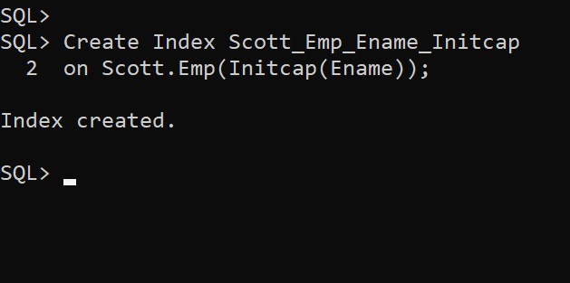

After indexing the column again reset memory and environment

Alter system flush buffer_cache;
Alter system flush shared_pool;
SET AUTOTRACE ON

Now execute the same select statement:

Select *
From Scott.Emp
Where Initcap(Ename) = 'Smith';

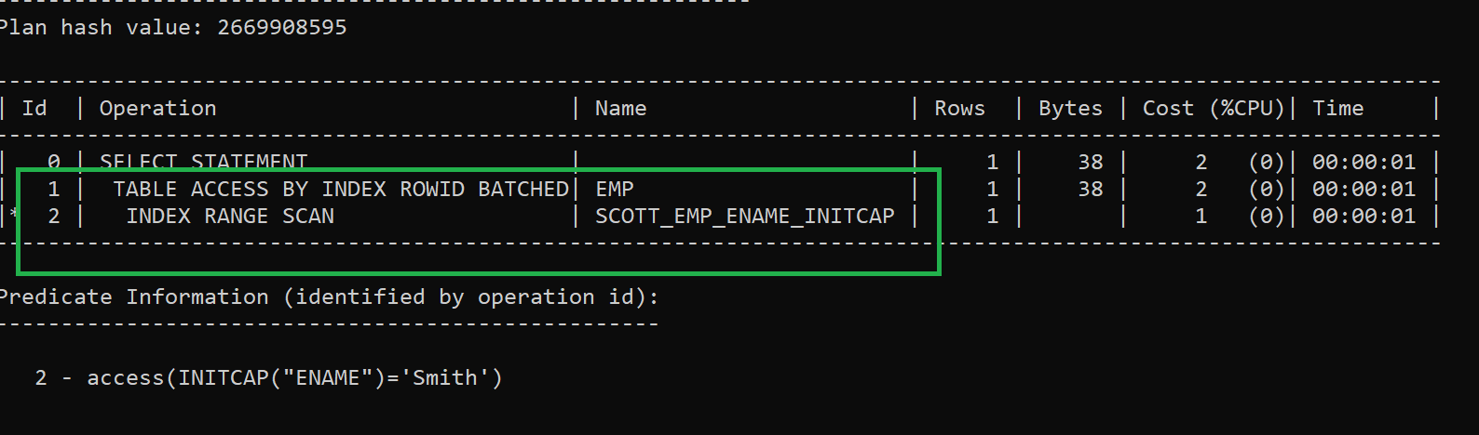

Finally, the index (function-based index) got used and Full Table Scan got avoided!!!

Reset memory and environment.

Alter system flush buffer_cache;
Alter system flush shared_pool;
SET AUTOTRACE ON

Using User Defined PLSQL Function in Function Based Index

The expression of the Function based Index can be a User Defined PLSQL function as well.
*** The only condition is that the function MUST have the clause Deterministic.

What is the clause Deterministic?
Answer A deterministic function is one that always produces the same output for the same set of input parameters, regardless of the database state or any other external factors. In other words, given the same input values, a deterministic function will consistently return the same result.

Here are some key points about deterministic functions:
1. Predictable Behavior: Deterministic functions are predictable because their output depends solely on their input parameters. They do not rely on any hidden state or external data.
2. *****Use in Indexes: When you create an index on a function-based column (i.e., an index based on the result of a function), Oracle requires that the function be deterministic. This ensures that the index remains consistent and reliable.
3. Marking Functions as Deterministic: In Oracle, you can explicitly mark a function as deterministic using the DETERMINISTIC keyword.

Non-Deterministic Functions: Conversely, a non-deterministic function is one that can produce different results for the same input parameters. Non-deterministic functions might depend on the current time, database state, or other external factors. You should avoid creating indexes on non-deterministic functions.

Examples:
Deterministic functions: Mathematical calculations (e.g., square root, absolute value), string manipulation (e.g., UPPER, LOWER), and date functions (e.g., TO_CHAR, TRUNC).
Non-deterministic functions: Functions that involve randomness (e.g., DBMS_RANDOM.VALUE), system time (e.g., SYSDATE), or package state.

Remember that using deterministic functions appropriately can improve query performance and maintain data consistency. If you encounter the ORA-30553 error, it’s likely related to the determinism of the function used in an index.

Demo:

create table policy_details
(policy_code varchar(80),
customer_id varchar(10),
amount integer);

Insert into policy_details Values('ps_C1', 'C1', 90000);
Insert into policy_details Values('ps_C2', 'C2', 80000);

commit;

Observe that as a writing convention the first 2 characters are always in lower case. User may not be aware of such minor things.

create or replace function right_policy_code(p_policy_code varchar)
return varchar Deterministic
as
v_pc varchar(80);
begin
v_pc := lower(substr(p_policy_code,1,2)) || substr(p_policy_code,3);
return v_pc;
end right_policy_code;

If Deterministic is not mentioned the function will get created without errors, but it will throw runtime error if used inside a function-based index.

-- Check the functionality using dual table

select right_policy_code('ABCDEF') from dual;

Now we will use this function while creating a Function Based Index.

create index ind_policy_code
on policy_details(right_policy_code(policy_code));

Alter system flush buffer_cache;
Alter system flush shared_pool;
Set AutoTrace On
Cle Scr

Select * from policy_details
Where right_policy_code(policy_code) = right_policy_code('PS_C1');

